

RFID ATTENDANCE SYSTEM WITH
GOOGLE SHEET

A PROJECT BASED LEARNING REPORT
Submitted by

HARIESH A (22EC023)
HARIHARAN T (22EC025)

KUMAR T (22EC046)

In partial fulfillment for the award of the degree of
BACHELOROFENGINEERING

in

ELECTRONICS AND COMMUNICATIONENGINEERING

DEPARTMENT OF ELECTRONICS AND COMMUNICATION ENGINEERING
NANDHA ENGINEERING COLLEGE, ERODE-52
(Autonomous)

(Affiliated to Anna University, Chennai)

DECEMBER 2024

NANDHA ENGINEERING COLLEGE
(Autonomous)
(Affiliated to Anna University, Chennai)

BONAFIDE CERTIFICATE
Certified that this project report “RFID ATTENDANCE SYSTEM WITH GOOGLE SHEET” is the bonafide work of “HARIESH.A (22EC023), HARIHARAN.T (22EC025), KUMAR.T (22EC046)”, who carried out the Project Based Learning work under my supervision

SIGNATURE

Mr.D.Anandakumar ME.,
Assistant Professor,
PBL CO-ORDINATOR,
Department of ECE,
Nandha Engineering College,
Erode-52.

ACKNOWLEDGEMENT

The success of a work depends on team effort and co-operation of various people involved either directly or indirectly.
We express our sincere thanks to our beloved Chairman of Sri Nandha Educational Trust Thiru.V.Shanmugan, and our beloved Secretary, Thiru.S.Thirumoorthi, of Nandha Engineering College for providing us all the basic amenities to complete the course successfully.
We wish to express our deep sense of gratitude and thanks to our beloved Principal Dr.U.S.Ragupathy, for the excellent facilities provided during the course study and project work.
We wish to express our hearty thanks to Dr.S.Kavitha, Professor & Dean, Dr.C.N.Marimuthu, Professor& Dean (R&D), Department of ECE for providing Continuous support during the project work.
We are highly indebted to our project guide Mr.D.Anandakumar, Assistant Professor, and Mr.M.Srinevasan, Assistant Professor, Project Lab In-charge, Department of ECE, for their guidance and motivation in completing the project.

We thank all the Teaching and Non-Teaching staff members of Electronics and Communication Engineering Department for their support to our project work. We also express our thanks to our family members and friends for their encouragement, timely help and suggestions.

ABSTRACT

The traditional manual attendance system is very time-consuming, It is insecure and this system can lead to human errors. This system is ineffective as our valuable time and work get wasted in organizing attendance on pen and paper. Hence to overcome this problem we have used a relational database system to store the real-time data of the students. For this project, we used RFID tags and readers to record the attendance of the students. To manipulate and represent the data based on the unique RFID tags, which get fast and easily scanned on the RFID reader. RFID technology is an automatic wireless identification system. This system is used to help the authority manage the attendance of students in a more organized, efficient, and time-saving manner. This particular system has been implemented in a prototype system that uses RFID tags and a reader to calculate attendance which proves its effectiveness over the normal attendance approach. The design of the system is simple, not expensive, and portable to use which makes it good for candidates and also for commercial and academic purposes.

TABLE OF CONTENTS
CHAPTER

PAGE TITLE
NO.
ABSTRACT iv
LIST OF TABLE v
LIST OF FIGURES vi
LIST OF SYMBOLS vii
1. INTRODUCTION 1
INTRODUCTION TO PROJECT WORK
1.2 OBJECTIVE
1.3 Embedded System
1.3.1 Applications of Embedded System
2. EXISTING SYSTEM 4
2.1 Block Diagram
2.2 Explanation
2.3 Disadvantages
3. PROPOSED SYSTEM 5
3.1 Block Diagram
3.1.1 Explanation

3.1.2 Advantages
4. HARDWARE DESCRIPTION 7
4.1. ESP32 Microcontroller
4.2. LCD 16x2
4.3 RFID Reader
4.4 RFID Tag and Card
4.5 Buzzer
4.6 Jumper wire
5. SOFTWARE DESCRIPTION 11
5.1 Arduino IDE
5.2 Coding
6. RESULT AND DISCUSSION 17
6.1 Result
6.2 Discussion
7. CONCLUSION AND FUTTURE SCOPE 18
7.1 Conclusion
7.2 Future Scope
APPENDICES 19
REFERENCES 19

LIST OF FIGURES

FIGURE NO | DESCRIPTION |  |  | PAGE NO
4.1.1 | ESP32 Microcontroller |  |  | 7
4.2.1 | LCD 16x2 |  |  | 8
4.3.1 | RFID Reader |  |  | 9
4.4.1 | RFID Tag and Card |  |  | 9
4.5.1 | Buzzer |  |  | 10
4.6.1 | Jumper wire |  |  | 10

LIST OF ABBREVATIONS

RFID Radio Frequency Identification
IOT Internet Of Things
LCD Liquid Crystal Display
IDE Integrated Development Environment
AI Artificial Intelligence
LED Light Emitting Diode
PCB Printed Circuit Board
API Application Programming Interface

CHAPTER-1
INTRODUCTION

  - INTRODUCTION TO PROJECT WORK
This project focuses on the implementation of a smart attendance management system using Radio Frequency Identification (RFID). In recent times technologies have minimized the time-consuming process which improves the fast response with high reliability. Hence the idea of RFID emerged to compensate for the requirement in terms of automation in real-time applications. The conventional methods are old enough and are still used in taking student attendance in many institutions and schools. This particular type of attendance system has many loopholes like a student can give fake attendance to friends. If the list is missed, they have to take reattendance, which is a very inefficient method. Right now, most of the researchers basically concentrating on RFID systems. The main advantage and utility feasibility of RFID is access control. This could be working in miscellaneous environments. All the engineers who are working towards developing their innovative products for real-time applications focus their work on RFID. The conventional methods can also create interruptions as a result of passing a sheet of papers around during academic lectures, conferences presentations, or workshops. It disturbs both student’s and the teacher’s attentiveness and concentration. This in turn reduces the effectiveness of such sessions.

.

  - OBJECTIVE

- Automate Attendance: Replace manual attendance processes with automatic RFID scanning for improved efficiency.
- Real-Time Data Sync: Instantly update attendance records in Google Sheets upon RFID card scan.
- Secure Identification: Use RFID tags to uniquely and securely identify individuals.
- Error Reduction: Minimize human error in attendance recording through automation.
- Cloud-Based Access: Store data in Google Sheets, making it accessible from anywhere.
- Simplified Reporting: Generate attendance reports easily from Google Sheets for analysis.
- Cost-Effective: Leverage existing Google Sheets features, reducing the need for expensive software.
- Time Management: Save time by eliminating manual data entry for attendance tracking.
- Scalable Solution: Design to accommodate growth in users or locations.
- Easy Integration: Seamlessly integrate the system with Google Sheets for smooth data management.

  - EMBEDDED SYSTEM
An embedded system is a specialized computing system that is designed to perform dedicated functions or tasks within a larger mechanical or electronic system.

1.3.1 Applications of Embedded System

- Schools/Colleges:
Automate student attendance and maintain class records.
- Offices:
Track employee attendance, work hours, and manage payroll data.
- Events/Conferences:
Monitor participant entry and exit for event management.
- Gyms/Fitness Centers:
Record member check-ins and track usage frequency.
- Libraries:
Manage visitor logs and usage of library facilities.
- Healthcare Centers:
Monitor staff attendance and patient movement for efficient management.
- Factories/Warehouses:
Track worker attendance and ensure safety compliance.
- Hostels/Dormitories:
Record student entry and exit times for security purposes.

CHAPTER-2
EXISTING SYSTEM

2.1 BLOCK DIAGRAM
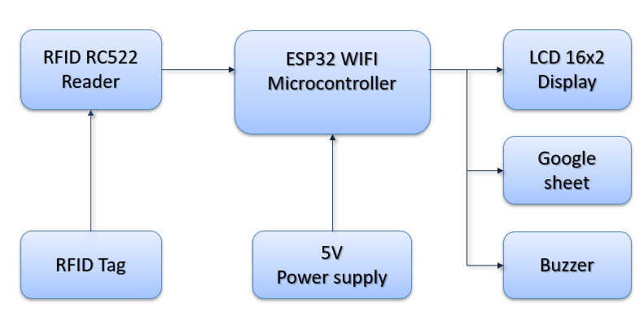
2.2 EXISTING EXPLANATION
An RFID attendance system with Google Sheets automates attendance tracking by using RFID cards/tags assigned to users. When scanned at an RFID reader, the unique ID is captured and transmitted to Google Sheets via an API or script, recording attendance in real-time. The system eliminates manual entry errors, provides instant data updates, and stores records in the cloud for easy access. It’s a cost-effective and scalable solution suitable for schools, offices, or organizations. Google Sheets allows for simple reporting and data analysis.

  - EXISTING PROJECT DISADVANTAGE
- Needs constant internet for real-time updates.
- Data may be vulnerable to breaches.
- Limited advanced features for customization.
- Difficult to manage large datasets.
- RFID cards can be cloned or hacked.
CHAPTER-3
PROPOSED SYSTEM

3.1 BLOCK DIAGRAM
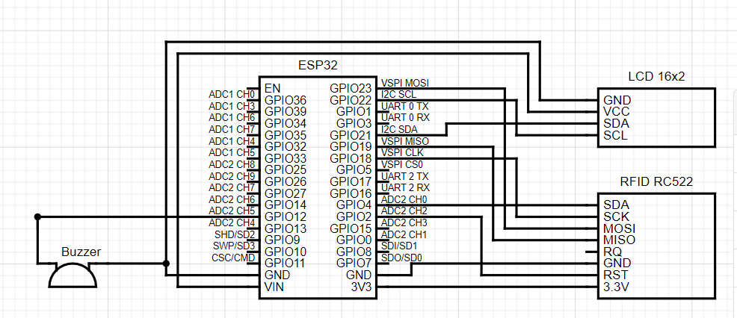

Block Diagram For RFID Attendance System With Google Sheet

3.1.1 Explanation
- Automated Attendance: RFID tags are assigned to users, and when scanned at an RFID reader, attendance is automatically logged without manual intervention.
- Real-Time Data Sync: The system instantly updates attendance records in Google Sheets, making them accessible from anywhere with an internet connection.
- Cloud-Based Storage: Google Sheets serves as a secure, cloud-based platform for easy reporting, data analysis, and collaboration on attendance records.

3.1.2 ADVANTAGES OF THE PROPOSED SYSTEM

- Real-Time Logging:
Immediate attendance updates in Google Sheets, accessible remotely.
- Cost-Effective:
Affordable hardware with easy scalability for larger setups.
- Automated Accuracy:
Minimizes manual errors and ensures precise data capture.
- Google Sheets Integration:
Easy data management, analysis, and collaboration.
- Customizable:
Flexible to adapt to specific needs and integrate with other systems.

CHAPTER-4
HARDWARE DESCRIPTION

4.1 ESP32 MICROCONTROLLER:
The ESP32 microcontroller is a powerful and versatile chip developed by Espressif Systems. It is part of the ESP (Espressif Systems Platform) family, and it has gained significant popularity in the maker, hobbyist, and IoT (Internet of Things) communities due to its impressive features and capabilities. Here are some key aspects of the ESP32 microcontroller. The ESP32 microcontroller is a powerful and versatile chip developed by Espressif Systems. It is part of the ESP (Espressif Systems Platform) family, and it has gained significant popularity in the maker, hobbyist, and IoT (Internet of Things) communities due to its impressive features and capabilities. Here are some key aspects of the ESP32 microcontroller
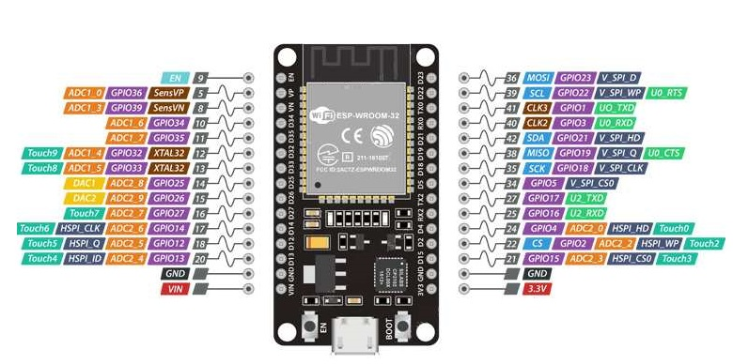
Figure 4.1.1: ESP32 Pin Configuration

4.2 LCD 16x2
A 16×2 LCD display is a liquid crystal display that can show 16 characters in each of its two rows, providing a total of 32 characters of information.
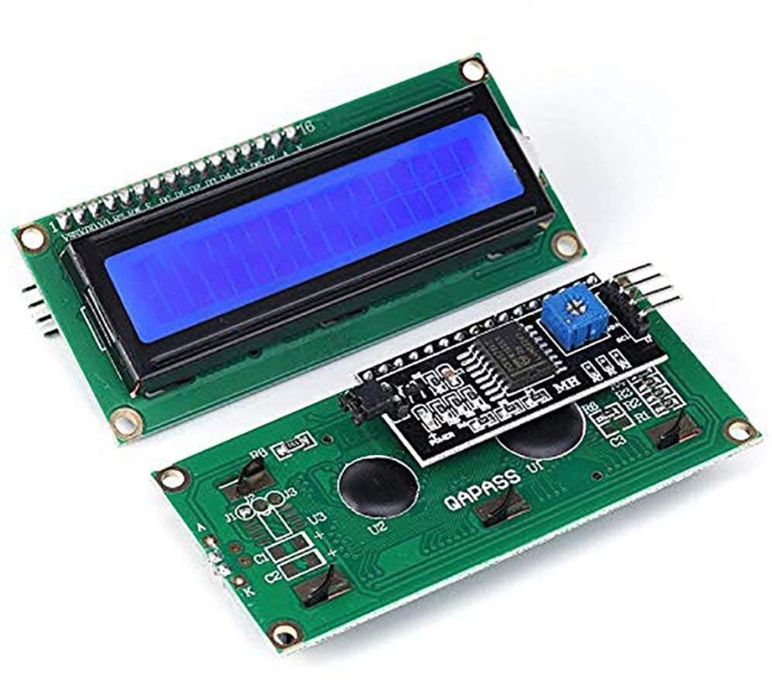

Figure 4.2.1: LCD 16x2

4.3 RFID Reader

An RFID reader consists of an antenna and a Radio frequency module which basically generates a high-frequency electromagnetic field. As we all know an RFID tag is a passive device which means that it doesn’t have a power supply or a battery. An RFID reader has a microchip that is used to store and process the information. And also it has an antenna that is used to receive to transmit a signal. To read the information on the RFID tag it needs to be placed in very close range of the reader. An RFID reader basically generates an electromagnetic field that causes electrons to move through the tag in the antenna and it powers up the chip.

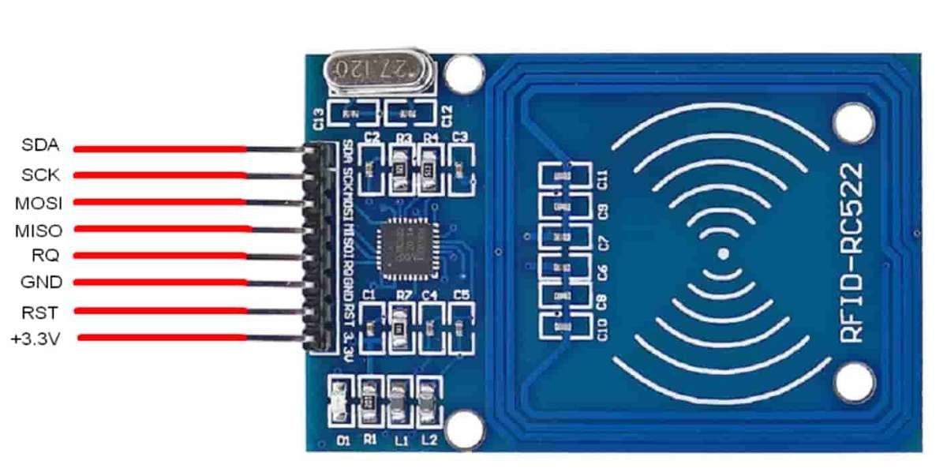

Figure 4.3.1 RFID RC522

4.4 RFID TAGS AND CARDS
The RFID tags are differentiated as passive and active tags. If the device doesn’t have its power supply it is called a passive RFID tag. Thus, The passive tags have to be in very close range of an RFID reader and make use of the radio waves which are broadcasted by the reader to power the response alternatively if the device has its battery power to perform entire operations which are called active RFID tags.

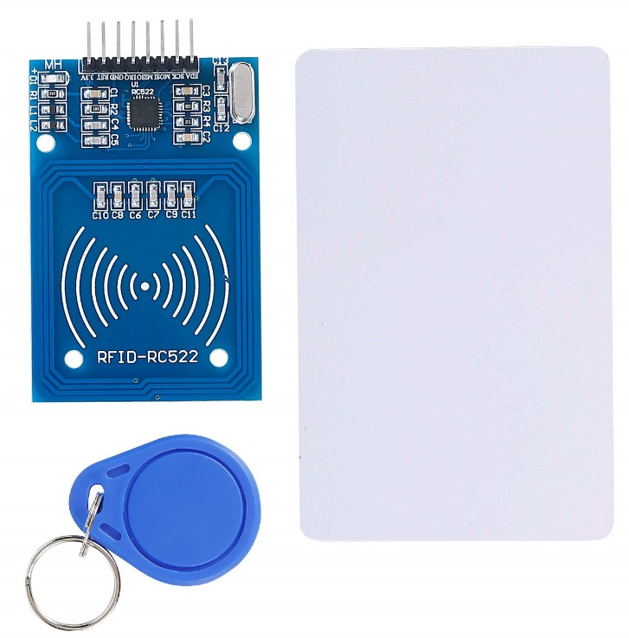

fig 4.4.1 RFID tags and cards
4.5 Buzzer
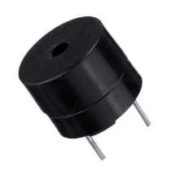

Figure 4.5.1 Buzzer

A buzzer is an electrical device that produces a buzzing sound. It is commonly used as a signaling device in various applications are alarms, games and quizzes, alarms, notification. Buzzers can vary in sound, from a simple tone to more complex sounds, depending on their design and purpose.

4.6 JUMPER WIRE

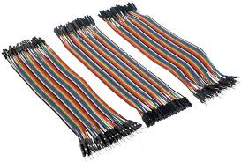
4.6.1 Jumper wire

Jumper wires are short electrical wires used to make temporary or permanent connections in circuits, often on breadboards. They come with different types of ends, such as male-to-male, male-to-female, and female-to-female connectors, allowing flexibility in connections. Jumper wires are typically insulated and come in various colors for easy identification. Commonly available lengths range from a few centimeters to several inches.

CHAPTER-5
SOFTWARE DESCRIPTION
5.1 ARDUINO IDE
The Arduino Integrated Development Environment (IDE) is a software application that provides a user-friendly platform for programming and uploading code to Arduino microcontrollers. It is a crucial tool for hobbyists, students, and professionals working with Arduino boards to create a wide range of electronic projects. The new major release of the Arduino IDE is faster and even more powerful! In addition to a more modern editor and a more responsive interface it features autocompletion, code navigation, and even a live debugger.

5.2 PROGRAM CODING

#include <Arduino.h>
#include <WiFi.h>
#include <SPI.h>
#include <MFRC522.h>
#include <HTTPClient.h>

#include <Wire.h>
#include <LiquidCrystal_I2C.h>

LiquidCrystal_I2C lcd(0x27, 16, 2);

//------------------------------------------------------------------------------------------------
// Enter Google Script Deployment ID:
const char *GScriptId = "AKfycby9RpfJnJBHVu3VGgf437m5p0ke5L80z5uViNamGVWXEegEFpnV95XzX8x8mGYLBd8adw";
//------------------------------------------------------------------------------------------------
// Enter network credentials:
const char* ssid = "********";
const char* password = "*********";
//------------------------------------------------------------------------------------------------
// Enter command (insert_row or append_row) and your Google Sheets sheet name (default is Sheet1):
String payload_base = "{\"command\": \"insert_row\", \"sheet_name\": \"Sheet1\", \"values\": ";
String payload = "";
//------------------------------------------------------------------------------------------------
// Google Sheets setup (do not edit)
const char* host = "script.google.com";
String url = String("/macros/s/") + GScriptId + "/exec";
//------------------------------------------------------------
// Declare variables that will be published to Google Sheets
String student_Rollno;
//------------------------------------------------------------
int blocks[] = {4,5,6,8,9};
#define total_blocks (sizeof(blocks) / sizeof(blocks[0]))
//------------------------------------------------------------
#define RST_PIN 2 // Customize these pins as per your ESP32 setup
#define SS_PIN 4
#define BUZZER 14
//------------------------------------------------------------
MFRC522 mfrc522(SS_PIN, RST_PIN);
MFRC522::MIFARE_Key key;
MFRC522::StatusCode status;
//------------------------------------------------------------
/* Be aware of Sector Trailer Blocks */
int blockNum = 2;
/* Create another array to read data from Block */
/* Length of buffer should be 2 Bytes more than the size of Block (16 Bytes) */
byte bufferLen = 18;
byte readBlockData[18];
//------------------------------------------------------------

/****************************************************************
* setup Function
****************************************************************/
void setup() {
//----------------------------------------------------------
pinMode(BUZZER, OUTPUT);
Serial.begin(115200);
delay(10);
Serial.println('\n');
//----------------------------------------------------------
SPI.begin();
//----------------------------------------------------------
// Initialize LCD screen
lcd.init();
// Turn on the backlight
lcd.backlight();
lcd.clear();
lcd.setCursor(0,0); //col=0 row=0
lcd.print("Connecting to");
lcd.setCursor(0,1); //col=0 row=0
lcd.print("WiFi...");
//----------------------------------------------------------
// Connect to WiFi
WiFi.begin(ssid, password);
Serial.print("Connecting to ");
Serial.print(ssid); Serial.println(" ...");

while (WiFi.status() != WL_CONNECTED) {
delay(1000);
Serial.print(".");
}
Serial.println('\n');
Serial.println("Connection established!");
Serial.print("IP address:\t");
Serial.println(WiFi.localIP());
//----------------------------------------------------------
lcd.clear();
lcd.setCursor(0,0); //col=0 row=0
lcd.print("Connecting to");
lcd.setCursor(0,1); //col=0 row=0
lcd.print("NEC website...");
delay(5000);
}

/****************************************************************
* loop Function
****************************************************************/
void loop() {
//----------------------------------------------------------------
lcd.clear();
lcd.setCursor(0,0); //col=0 row=0
lcd.print("Scan your ID");
lcd.setCursor(0,1);
lcd.print("Card or Tag...");
/* Initialize MFRC522 Module */
mfrc522.PCD_Init();
/* Look for new cards */
/* Reset the loop if no new card is present on RC522 Reader */
if ( ! mfrc522.PICC_IsNewCardPresent()) {return;}
/* Select one of the cards */
if ( ! mfrc522.PICC_ReadCardSerial()) {return;}
/* Read data from the same block */
Serial.println();
Serial.println(F("Reading last data from RFID..."));
//----------------------------------------------------------------
String values = "", data;

// Creating payload
for (byte i = 0; i < total_blocks; i++) {
ReadDataFromBlock(blocks[i], readBlockData);
//*************************************************
if(i == 0){
data = String((char*)readBlockData);
data.trim();
student_Rollno = data;
values = "\"" + data + ",";
}
//*************************************************
else if(i == total_blocks-1){
data = String((char*)readBlockData);
data.trim();
values += data + "\"}";
}
//*************************************************
else{
data = String((char*)readBlockData);
data.trim();
values += data + ",";
}
}
//----------------------------------------------------------------
// Create json object string to send to Google Sheets
payload = payload_base + values;
//----------------------------------------------------------------
lcd.clear();
lcd.setCursor(0,0); //col=0 row=0
lcd.print("Storing Data");
lcd.setCursor(0,1); //col=0 row=0
lcd.print("Please Wait...");
//----------------------------------------------------------------
// Publish data to Google Sheets
Serial.println("Publishing data...");
Serial.println(payload);

if(WiFi.status() == WL_CONNECTED) {
HTTPClient http;
http.begin("https://" + String(host) + url);
http.addHeader("Content-Type", "application/json");

int httpCode = http.POST(payload);
if(httpCode > 0) {
if(httpCode == HTTP_CODE_OK) {
lcd.clear();
lcd.setCursor(0,0); //col=0 row=0
lcd.print("Roll no: "+student_Rollno);
lcd.setCursor(0,1); //col=0 row=0
lcd.print("Present");
digitalWrite(BUZZER, HIGH);
delay(2000);
digitalWrite(BUZZER, LOW);
delay(2000);
}
} else {
Serial.println("Error on HTTP request");
lcd.clear();
lcd.setCursor(0,0); //col=0 row=0
lcd.print("Failed.");
lcd.setCursor(0,1); //col=0 row=0
lcd.print("Try Again");
}
http.end(); // Free resources
}
//----------------------------------------------------------------
// A delay of several seconds is required before publishing again
delay(5000);
}

/****************************************************************
* ReadDataFromBlock() function
****************************************************************/
void ReadDataFromBlock(int blockNum, byte readBlockData[])
{
//----------------------------------------------------------------------------
/* Prepare the key for authentication */
/* All keys are set to FFFFFFFFFFFFh at chip delivery from the factory */
for (byte i = 0; i < 6; i++) {
key.keyByte[i] = 0xFF;
}
//----------------------------------------------------------------------------
/* Authenticating the desired data block for Read access using Key A */
status = mfrc522.PCD_Authenticate(MFRC522::PICC_CMD_MF_AUTH_KEY_A, blockNum, &key, &(mfrc522.uid));
if (status != MFRC522::STATUS_OK){
Serial.print("Authentication failed for Read: ");
Serial.println(mfrc522.GetStatusCodeName(status));
return;
} else {
Serial.println("Authentication success");
}
//----------------------------------------------------------------------------
/* Reading data from the Block */
status = mfrc522.MIFARE_Read(blockNum, readBlockData, &bufferLen);
if (status != MFRC522::STATUS_OK) {
Serial.print("Reading failed: ");
Serial.println(mfrc522.GetStatusCodeName(status));
return;
} else {
readBlockData[16] = ' ';
readBlockData[17] = ' ';
Serial.println("Block was read successfully");
}
//----------------------------------------------------------------------------
}

CHAPTER-6
RESULT AND DISCUSSION

6.1 RESULT
The RFID attendance system integrated with Google Sheets delivers an automated, real-time attendance tracking solution. It reduces manual errors and saves time by instantly logging attendance upon scanning RFID cards. Attendance records are stored in Google Sheets, making them easily accessible and shareable. The system is scalable, cost-effective, and ideal for schools, offices, and events. Additionally, it provides reliable cloud-based storage for data analysis and reporting.

6.2 DISCUSSION
The RFID attendance system integrated with Google Sheets offers a modern, automated approach to managing attendance. While it provides real-time updates and cloud-based storage for easy access and reporting, there are considerations like data security and internet dependency. Its ease of use, scalability, and cost-effectiveness make it ideal for schools, offices, and other organizations. However, concerns about RFID card vulnerability and handling large datasets in Google Sheets should be addressed. Overall, it’s a practical solution but may require additional safeguards and scalability planning.

CHAPTER-7
CONCLUSION AND FUTTURE SCOPE

7.1 CONCLUSION
In conclusion, the RFID attendance system integrated with Google Sheets offers an efficient and automated method for tracking attendance across various environments. Its ability to provide real-time updates and secure cloud storage enhances accessibility and data management. While it presents challenges such as data security and scalability, its advantages, including cost-effectiveness and ease of use, make it a compelling solution. Implementing this system can significantly streamline attendance processes and improve overall productivity. With careful planning, it can effectively meet the attendance management needs of schools, offices, and organizations.

7.2 FUTURE SCOPE
The future scope of RFID attendance systems integrated with Google Sheets includes enhanced security features, such as encryption and multi-factor authentication, to safeguard data. Advances in RFID technology may enable more precise tracking and integration with other systems, like biometric authentication. Additionally, machine learning algorithms could analyze attendance patterns for insights into productivity and engagement. Expansion into mobile applications can allow users to manage attendance from their smartphones, increasing convenience. Overall, as technology evolves, this system can adapt to meet growing demands for efficiency and security in attendance management.

APPENDICES

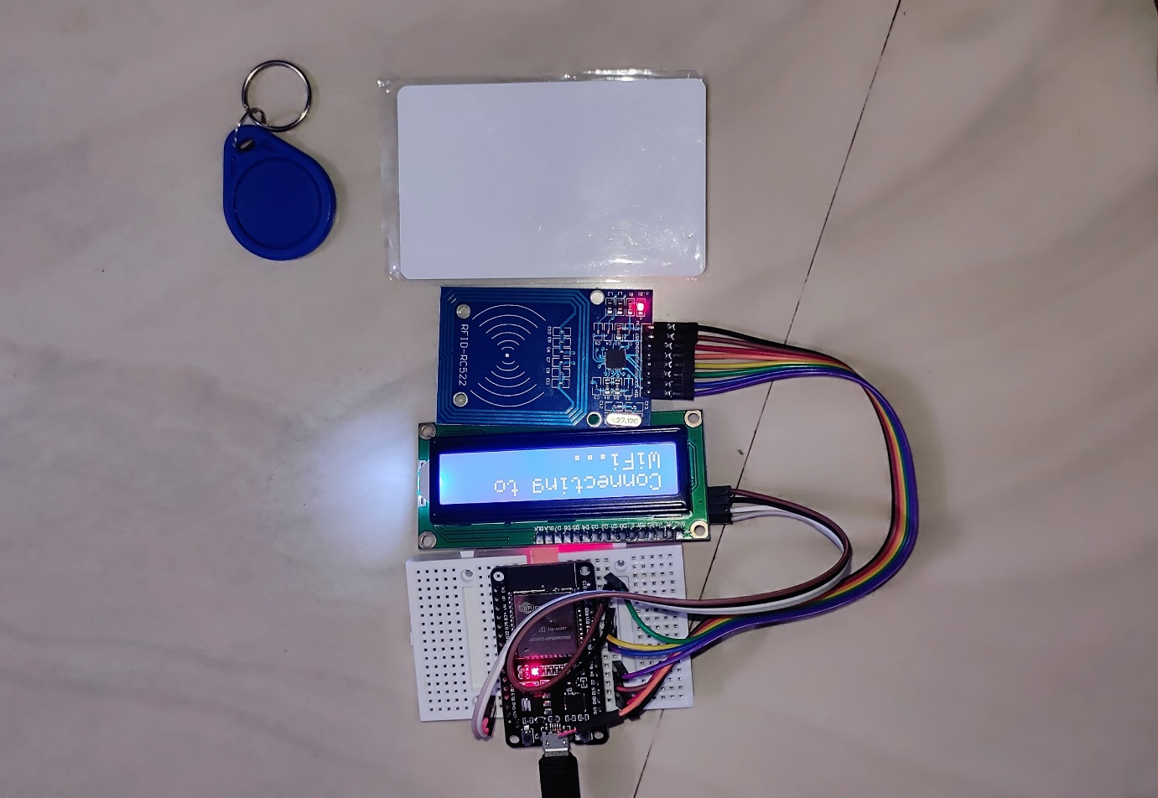

REFERENCES

- https://youtu.be/XxrxwEmDEEo?si=NEoP_MbvG238zyTX

